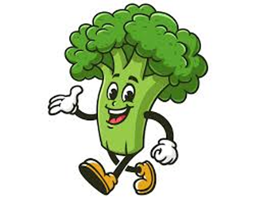
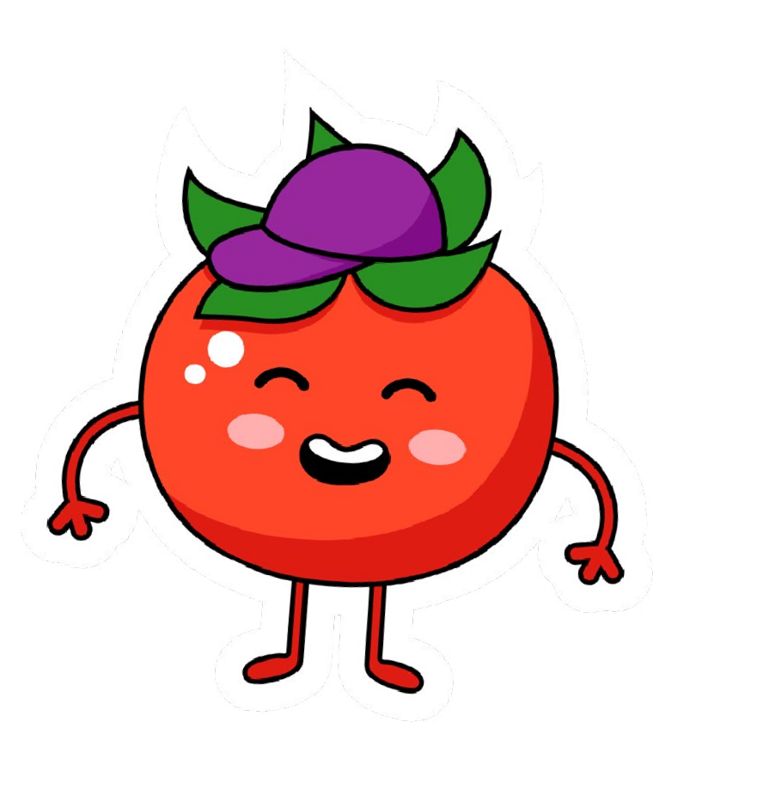

Spring / Summer Menu – Week 1
Week Commencing: 16.03.26/20.04.26/11.05.26

 | Monday | Tuesday | Wednesday | Thursday | Friday
Option 1 | Cheese & Tomato Whirl  With Sweetcorn, Carrots  & Herby Diced Potatoes | Beef Burger in a Bun  With Spaghetti Hoops, Peas, Coleslaw  & Salad Bar | All Day Breakfast  With Sausage, Bacon, Omelette, Beans  & Hash Browns | **NEW**  Spicy Chicken Noodles  With  Mini Vegetable Spring Rolls | Birds Eye Fishfingers  McCain Chips  & Beans
Option 2 | **NEW**  Omelette Plain or Cheese  Sweetcorn, Carrots  & Herby Diced Potatoes |  |  |  | **NEW**  Large Fish Nuggets  McCain Chips  & Beans
GRAB & GO
Filled roll with a choice of fillings – Ham, Cheese or Tuna Mayonnaise, Fruit, Salad Bar, Water or Milk
and Dessert

JACKET POTATOES AVAILABLE MONDAY-THURSDAY
NO JACKET POTATOES ON FRIDAY

For Dessert | Strawberry  or  Chocolate Mousse | Fresh Fruit Platter | Choice of Biscuit | Orange  Or  Strawberry Jelly | Old School Sponge Cake
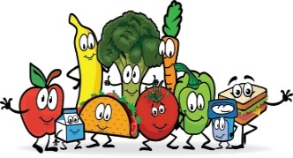
Salad Bar, yoghurts and fresh fruit available everyday
Please note menus may change with little or no notice due to supplier issues




Spring / Summer Menu – Week 2
Week Commencing: 23.03.26/27.04.26/18.05.26

 | Monday | Tuesday | Wednesday | Thursday | Friday
Option 1 | Cheese & Tomato Pizza  with Sweetcorn, Salad Bar  & Potato Wedges | Mild Chicken Curry with Rice  & Naan Bread | Roast Chicken with  Yorkshire Pudding, Roast Potatoes, Carrots, Cauliflower  & Bisto Gravy | Butchers Sausage in a Hotdog Roll  With Beans, Coleslaw  & Corn on The Cob | Birds Eye Fishfingers  McCain Chips  & Peas
Option 2 |  |  |  |  | **NEW**  Large Fish Nuggets  McCain Chips  & Peas
GRAB & GO
Filled roll with a choice of fillings – Ham, Cheese or Tuna Mayonnaise, Fruit, Salad Bar, Water or Milk
and Dessert

JACKET POTATOES AVAILABLE MONDAY-THURSDAY
NO JACKET POTATOES ON FRIDAY

For Dessert | Tub of Ice Cream | Flapjack | Fresh Fruit Platter | Waffle with option of Squirty Cream  & Sprinkles | Chocolate Sponge
Salad Bar, yoghurts and fresh fruit available everyday
Please note menus may change with little or no notice due to supplier issues

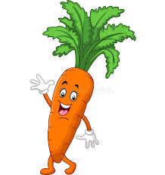


Spring / Summer Menu – Week 3
Week Commencing: 13.04.26/04.04.26

 | Monday | Tuesday | Wednesday | Thursday | Friday
Option 1 | Macaroni Cheese  With Garlic Bread  & Salad Bar | **NEW**  Chicken Goujons  With Smiley Faces, Baked Beans &  Pick Your Dip (BBQ, Sweet Chilli, Tomato Ketchup or Mayo) | Roast Turkey with Yorkshire Pudding, Roast Potatoes, Carrots, Broccoli  & Bisto Gravy | Meatballs in a Tomato Sauce  with Pasta  & Salad Bar | Birds Eye Fishfingers  McCain Chips  & Peas
Option 2 | **NEW**  Vegetarian Lasagne  With Garlic Bread  & Salad Bar |  | **NEW**  Homemade Chicken Pie with Yorkshire Pudding, Roast Potatoes, Carrots, Broccoli & Bisto Gravy |  | **NEW**  Large Fish Nuggets  McCain Chips  & Peas
GRAB & GO
Filled roll with a choice of fillings – Ham, Cheese or Tuna Mayonnaise, Fruit, Salad Bar, Water or Milk
and Dessert

JACKET POTATOES AVAILABLE MONDAY-THURSDAY
NO JACKET POTATOES ON FRIDAY

For Dessert | Organic Rainbow Fruit Lolly | Peaches & Cream  Or Yoghurt | Artic Roll | Fresh Fruit Platter | Cupcake
Salad Bar, yoghurts and fresh fruit available everyday
Please note menus may change with little or no notice due to supplier issues

