Y5/6 Sportshall Competition

Date: Monday, 28th January 2019

Venue: Ramsey Academy

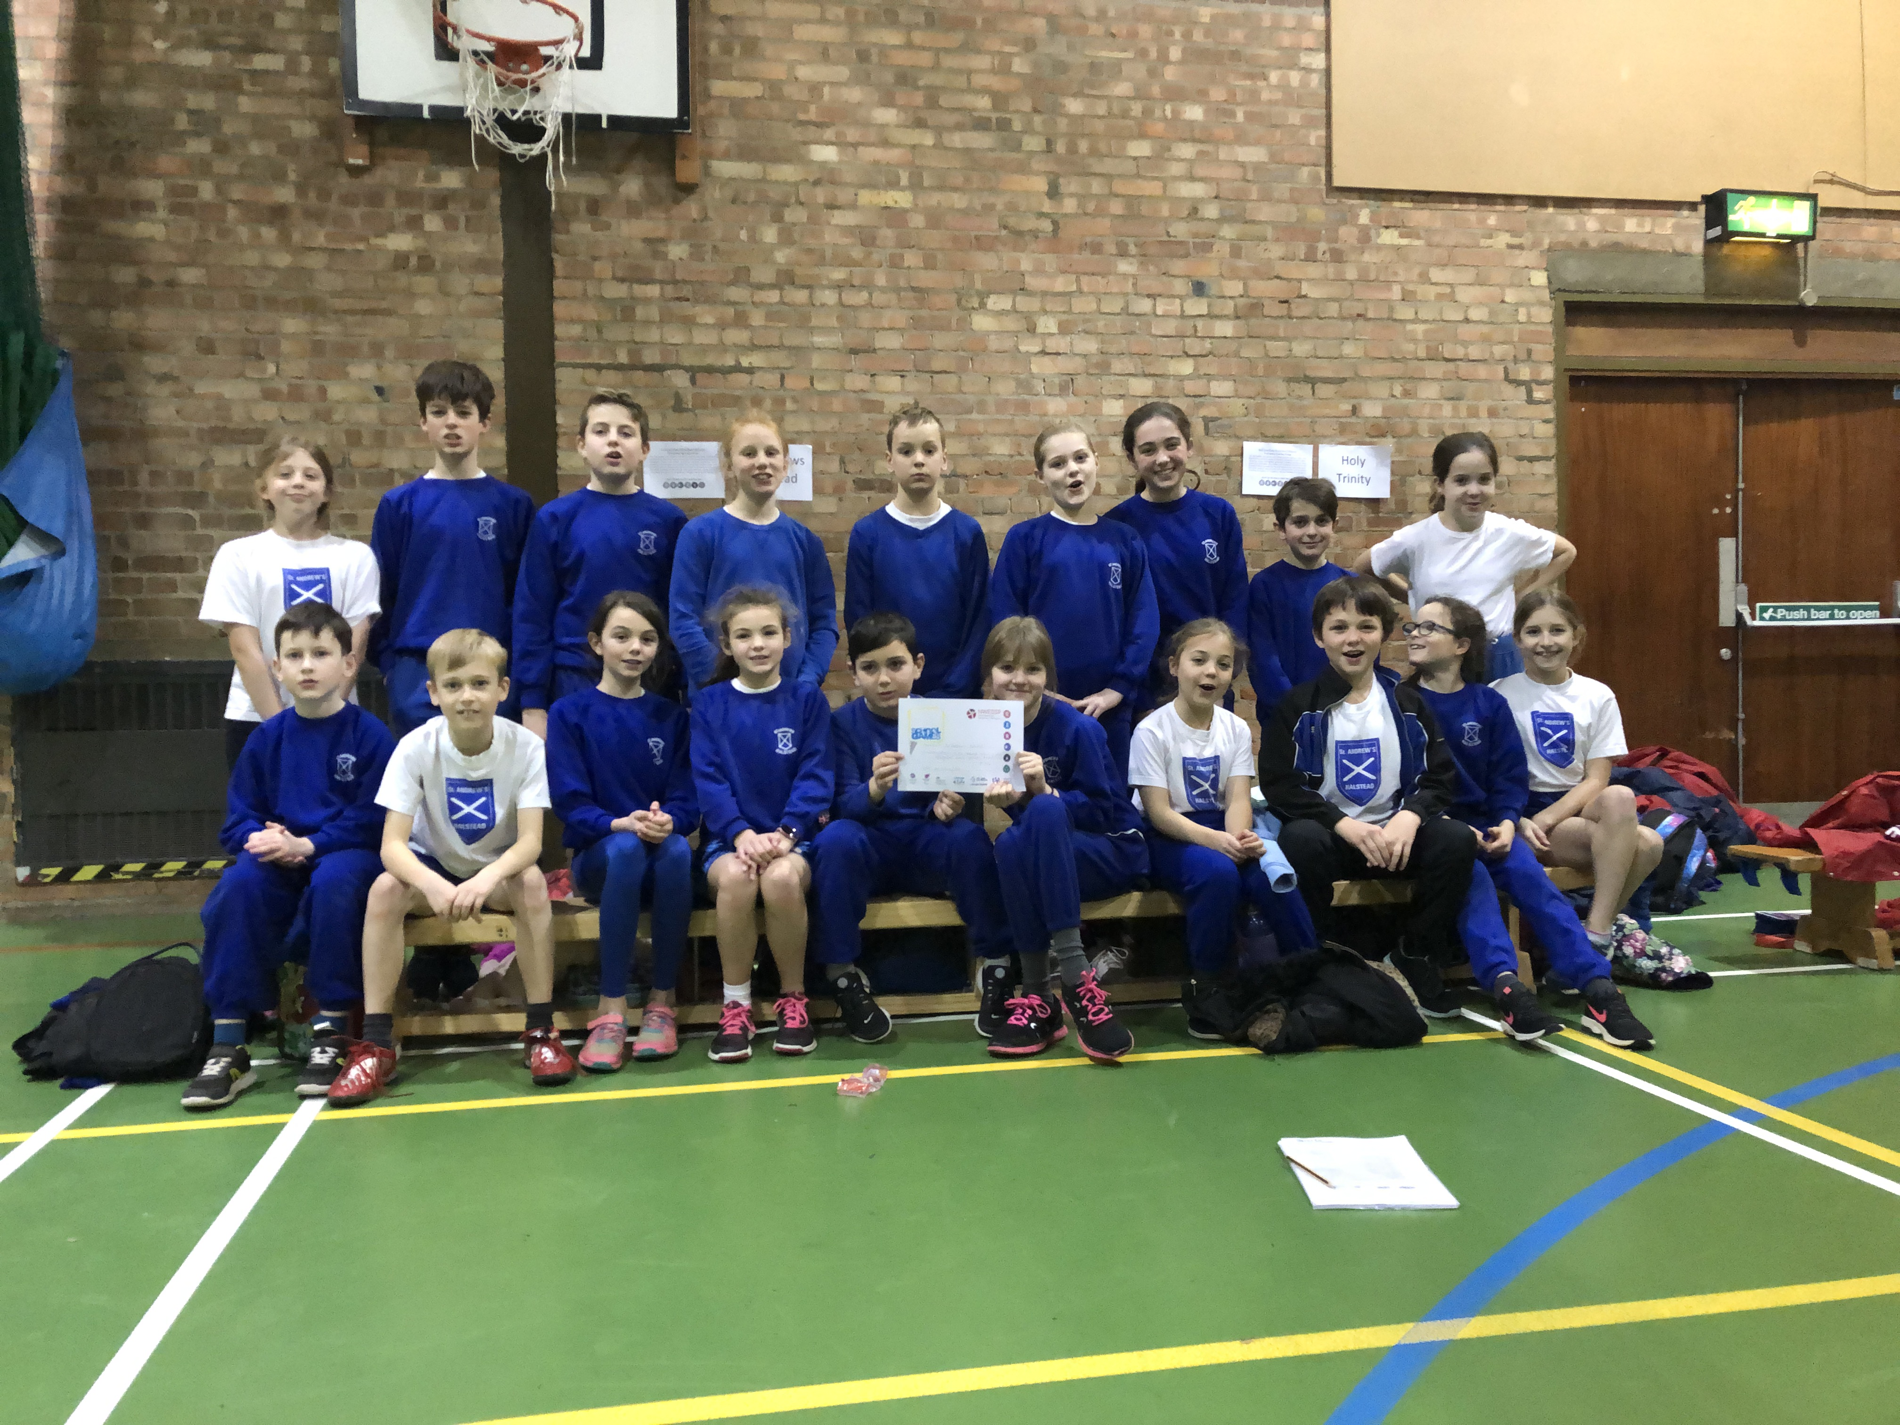

On Monday, 28th January 2019, a team of 20 St Andrews children took part in the L2 Qualifier Sportshall Competition, held at Ramsey Academy.

There were 8 schools competing over a mixture of 12 indoor track and field events.

It was a very loud and exciting competition and our team ran, jump and threw their hearts out. After some very close finishes, we came 5th out of the 8 schools.

The children demonstrated all the St Andrews Core values and were a pleasure to take.

Well done St Andrews.

