Level 2 Qualifier Dodgeball Competition

Date: Monday, 12th November 2018
Venue: Ramsey Academy

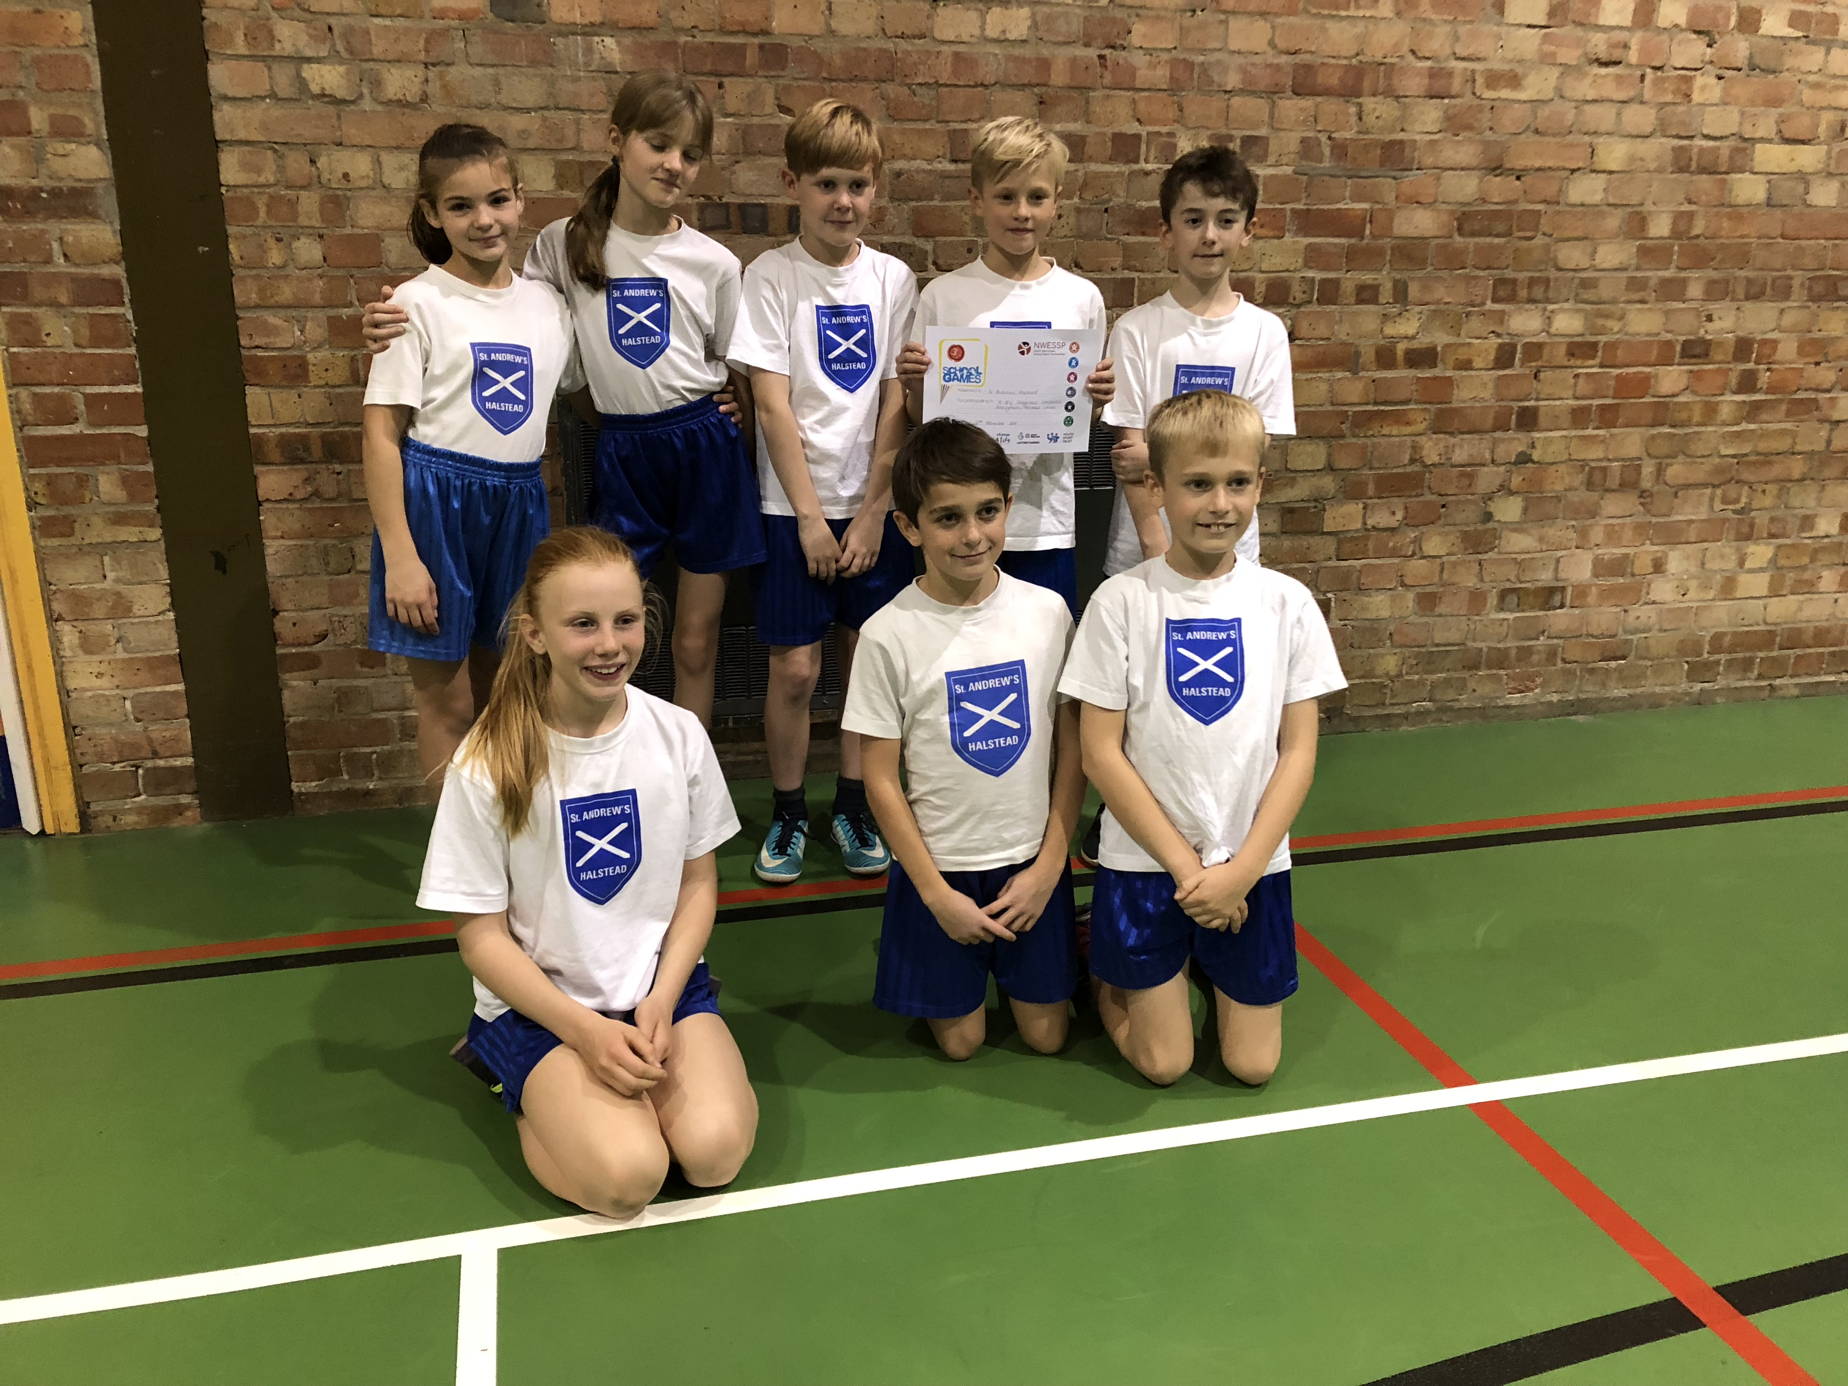

On 12th November 2018 a group of Y5 & 6 including Sunny, Jonnie, Theo, Freia, Daisy, Phebe, Sam and Charlie competed in a Dodgeball competition at Ramsey Academy.

There were 7 teams which were competing in the competition. We won our first game 2:1, in our second game we won 3:0. We lost 1:2 in our third game and then in our fourth game we won 3:0 again.

We came third but the team that came second broke the rules because they didn’t have enough girls, so this gave us the opportunity to advance to the next round which will be held at Ramsey Academy on the 5th December.

We all played extremely well, especially the year 5s because they had never played a Dodgeball tournament before.

We are very pleased with our results and we thoroughly enjoyed the experience. We would like to say a huge thank you to Mrs Roche and Mrs Press. It wouldn’t have been possible without them.

Written by: Sunny, Jonathan, Freia, Phebe, Daisy, Theo (Y6)

