Y1 Teddylympics

Date: Wednesday, 26th September 2018

Venue: Ramsey Academy

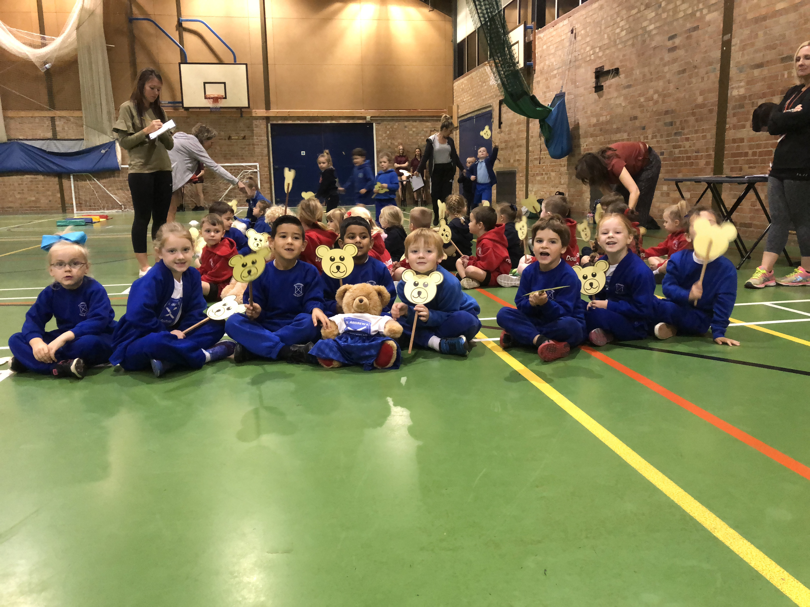

Congratulations to Tahir Khan, Archie Raynor, Maxim Giovine, Eddie Stacey, Eva Brown, Ruby Foakes, Elissa Nicholls and Daisy Petheridge who represented St Andrew’s for the first time at the recent Y1 Teddylympics event. The children worked well as a team and took part in 12 different indoor mini Sportshall athletics activities. They demonstrated all of the core St Andrews values and thoroughly enjoyed themselves! Well done Y1!

