Cross Country Competition

Date: Wednesday, 7th March 2018

Venue: Tabor College, Braintree

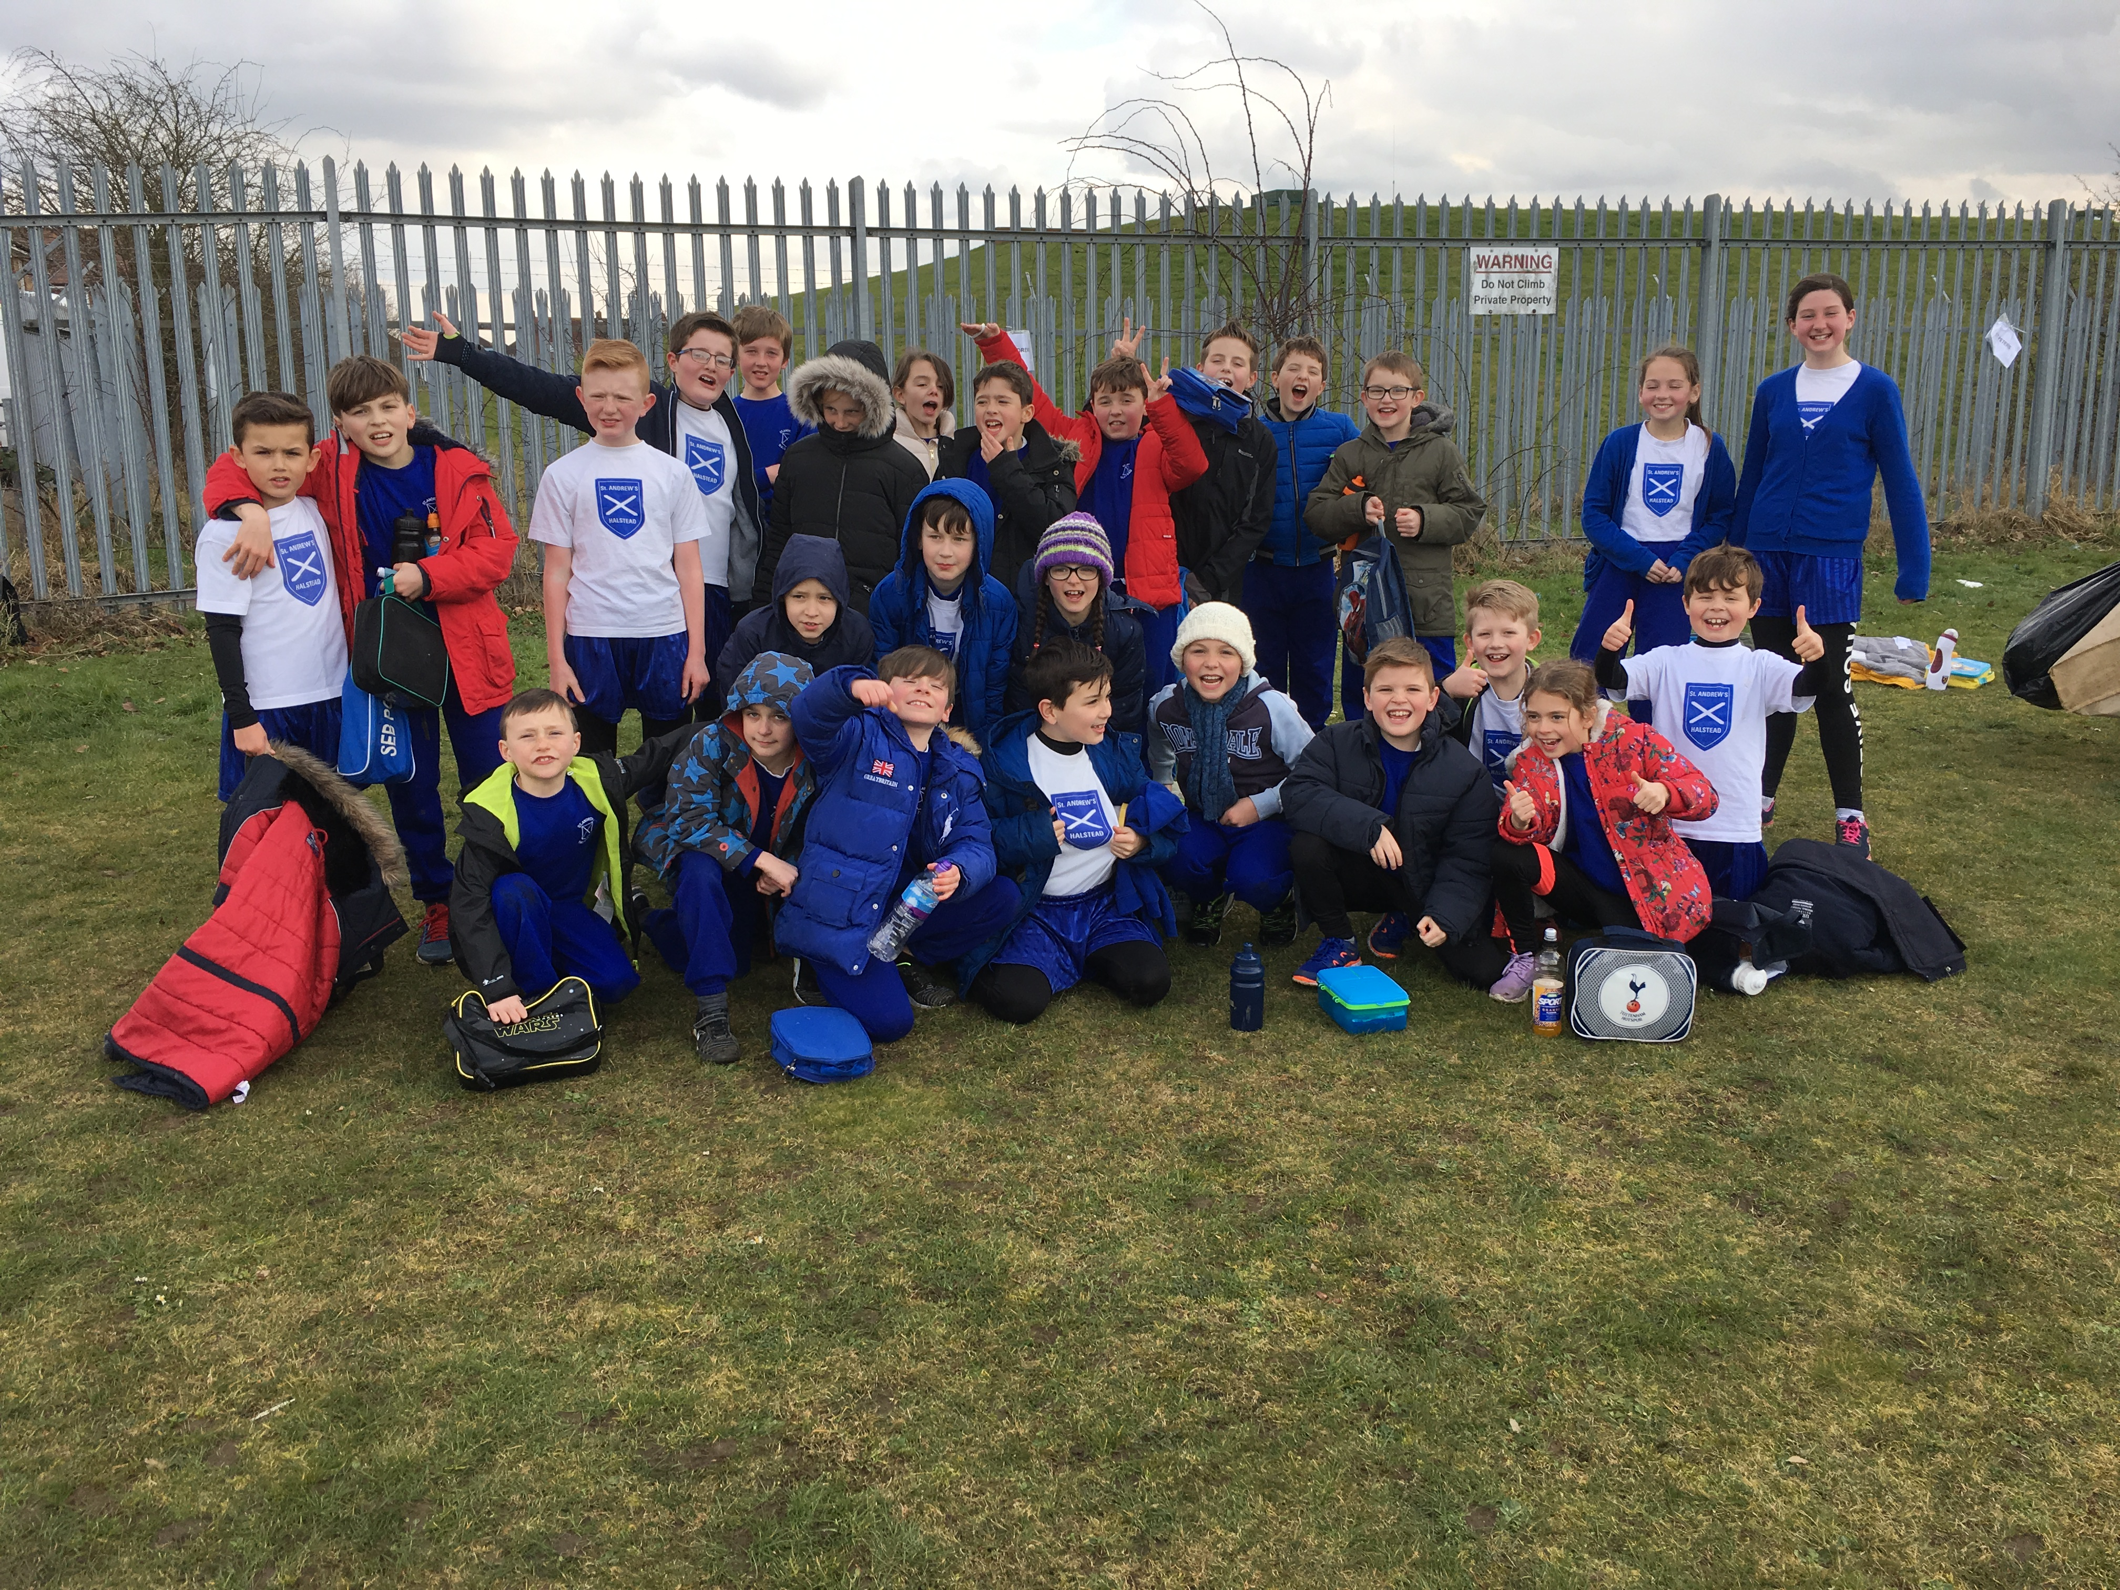

On Wednesday 7th March 2018, a team of 26 runners from St Andrews Years 3,4, 5 and 6 took part in a L2 Qualifier competition held at Tabor College, Braintree. For years 3 & 4 the race was run over 900m and years 5 & 6 ran 1500m. All the teams ran brilliantly with some years having between 40 – 80 runners!! We had some fantastic individual performances with 6 children progressing through to the L2 final at Ramsey Academy – well done to Nancy Gough, Abigail Prince, Charlie Underwood, Isabel Harris, Freia Challis and Connie Buckingham.

Mrs Press would like to say a huge thankyou to all the runners for their efforts on the day of the competition and for the dedication and commitment they have shown week after week at running club. She is extremely proud of each and every one of you and the incredible way the team supported each other and also the other schools.

A big thanks also to Mrs Gough who braved the cold to support the St Andrews team.

Well done everyone!!



