Tri Golf L2 Competition

Date: Wednesday, 28th March 2018

Venue: Colne Valley Golf Course

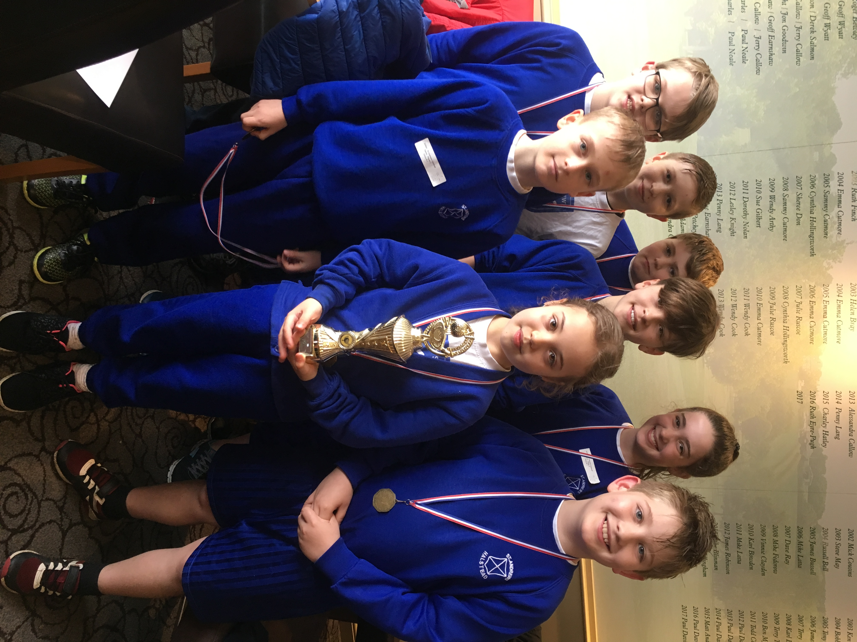

On Wednesday 28th March 2018 a team of 8 children from Years 4,5 & 6 represented St Andrews for the first time at a Level 2 Tri Golf Festival at the Colne Valley Golf course. The team played against 3 other schools and had to complete a series of 7 putting and chipping games. The weather was absolutely awful and everyone got completely frozen and soaked to the skin! However, St Andrews team spirit shone through and we won the overall competition with a huge score of 299 points!!! This means that St Andrews will now go through to the Level 3 county final in May!!

Mrs Press would like to say well done to the children and a big thank you to Mrs Green for helping to escort the children.

