Dodgeball L2 Competition

Date: Wednesday, 5th December 2018

Venue: Ramsey Academy

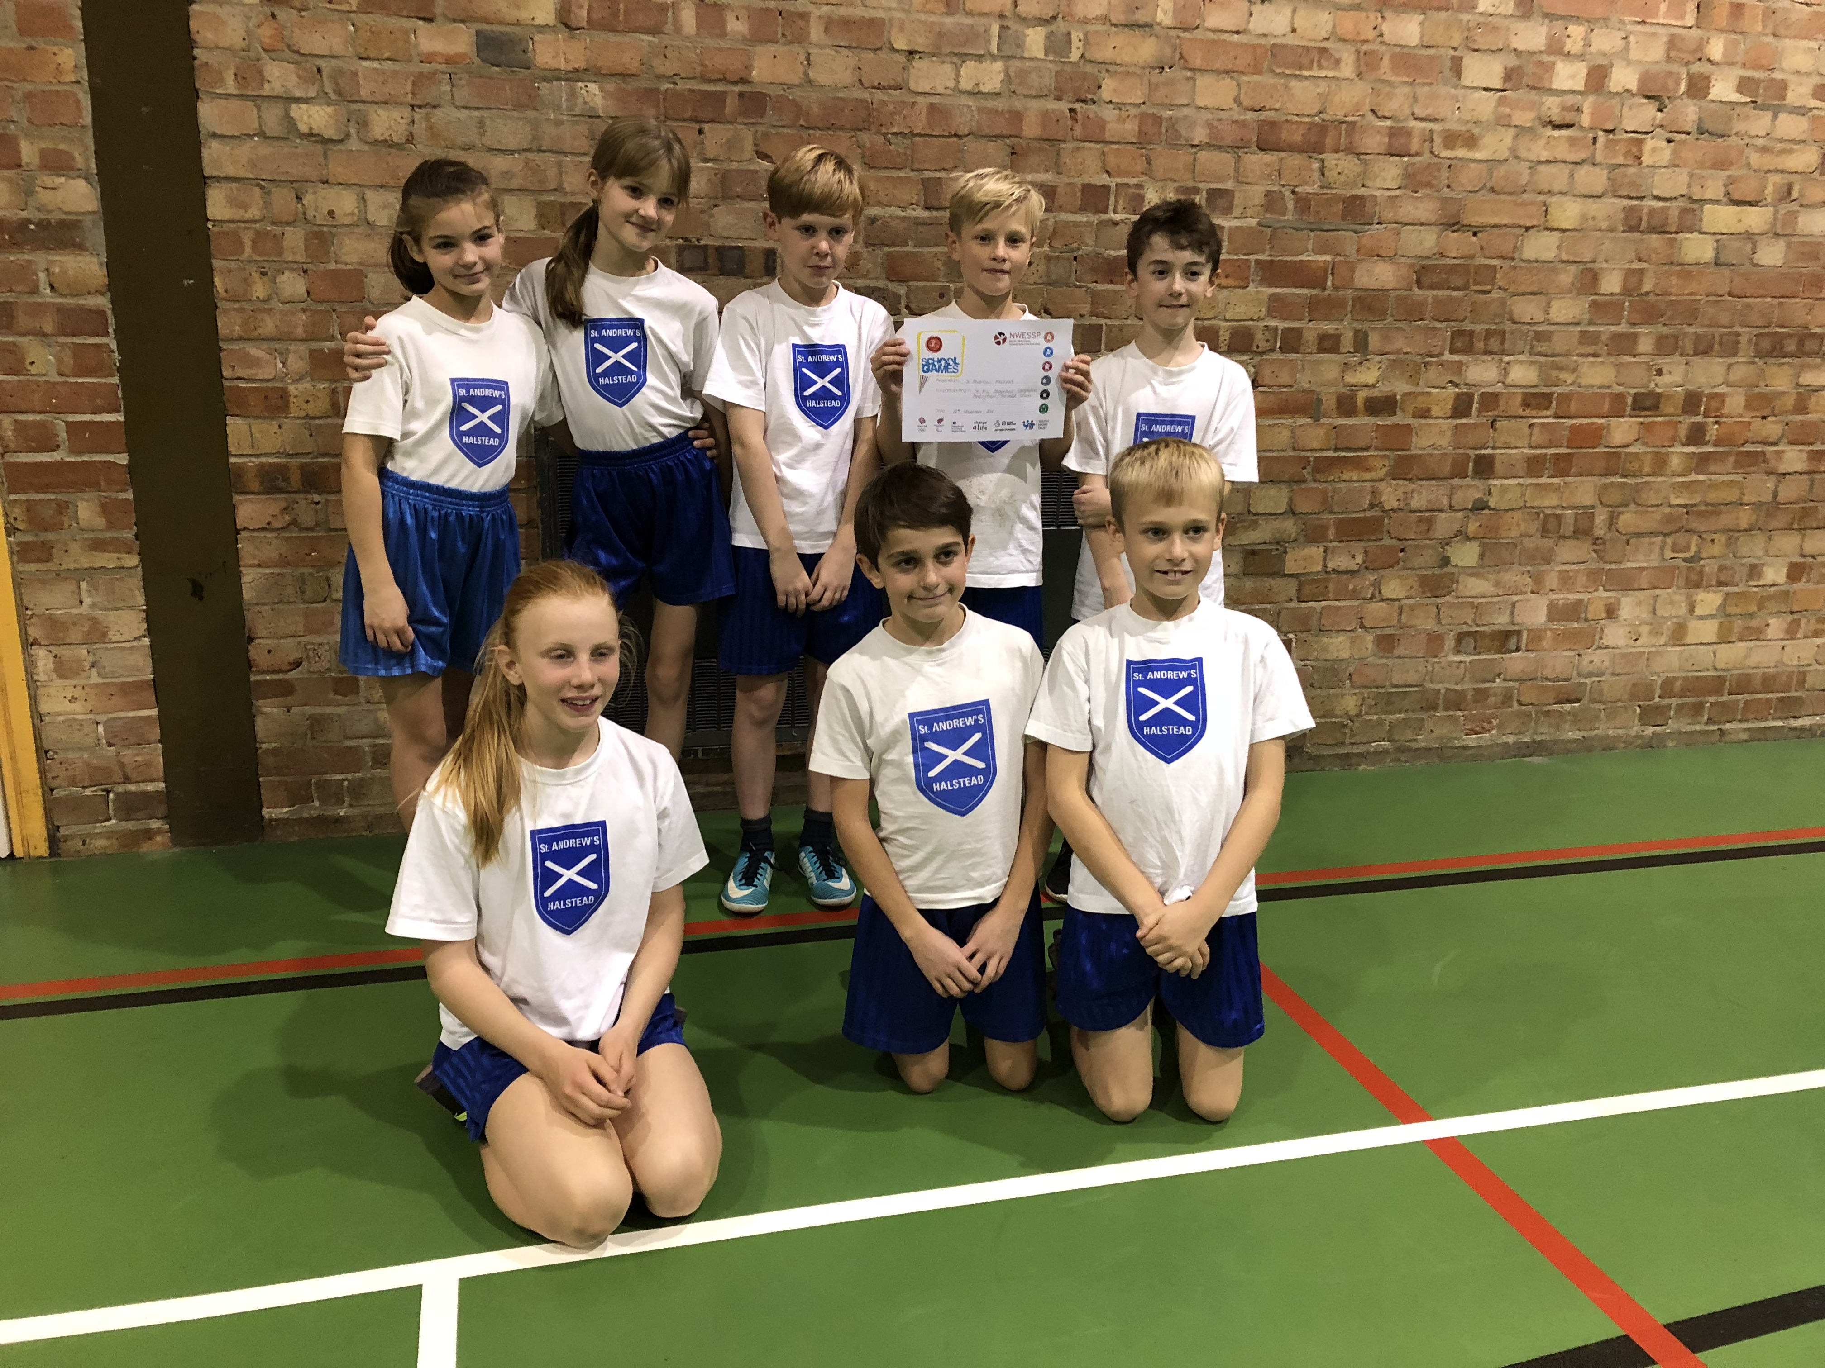

On the 5th December 2018 a group of children including Sunny, Freia, Jonnie, Theo, Daisy, Phebe, Sam and Charlie took part in the Level 2 Dodgeball competition.

We had 4 games and 2 “friendly” matches. In our first game we lost 3-0, in our second game we won 2-1, in our 3rd game we drew 1-1 and in our 4th we won 3-0. In the “friendlies” we won 3-0 in the first and 3-0 in the second.

All of our team had improved immensely since the last time we played. The teams were all really good and the matches were really close. Overall we came third out of 5 teams.

Thankyou to Mrs Roche and Mrs Press for taking us to the competition, it wouldn’t have been possible without you.

Written by: Sunny, Jonnie, Freia, Phebe Y6

