**KS2 Open Football Competition**

**Date: Monday, 25th September 2023**

**Venue: Ramsey Academy**

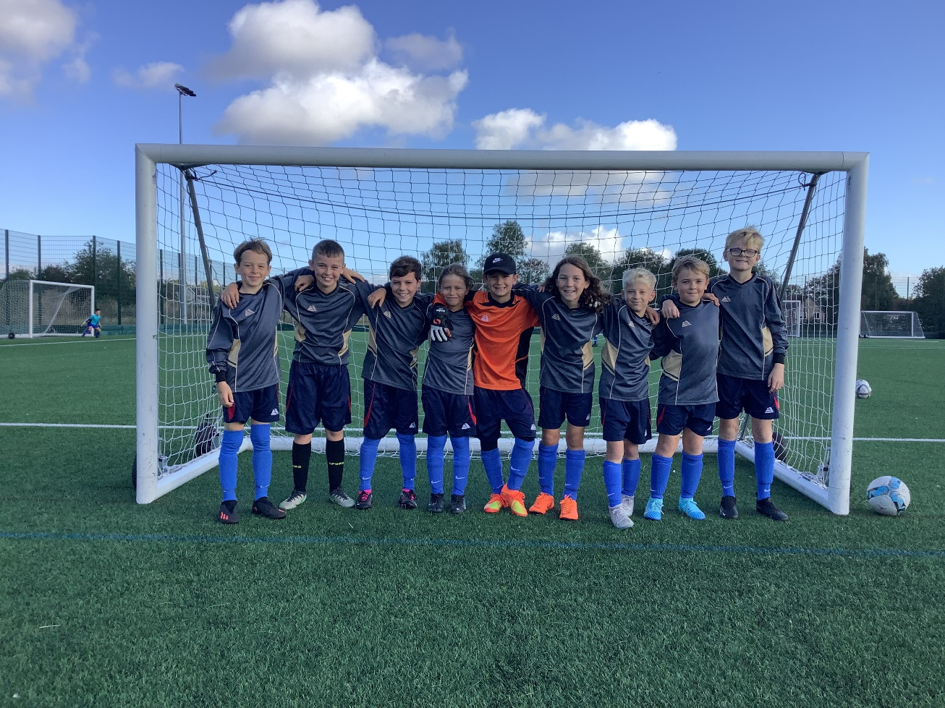

On the 25th September 2023 we competed in a KS2 football competition. The team was made up of Harrison, Kayden, Stanley N, Stanley W, Seb, Darcy, Teddy, Louis and Jacob.

We played 6 matches in total. In our first game we drew 0-0. In our second game we lost 2-1 with Louis scoring the only goal. In our third game we lost 3-0. In our fourth game we won 1-0 with Jacob scoring the winning goal and in our last game

This was the first time the team have played together and we tried lots of tactics and formations. All the teams at the tournament played really well and we came sixth out of seven teams overall.