KS2 Girls football competition 2023

Date: Tuesday, 19th September

Venue: Ramsey Academy

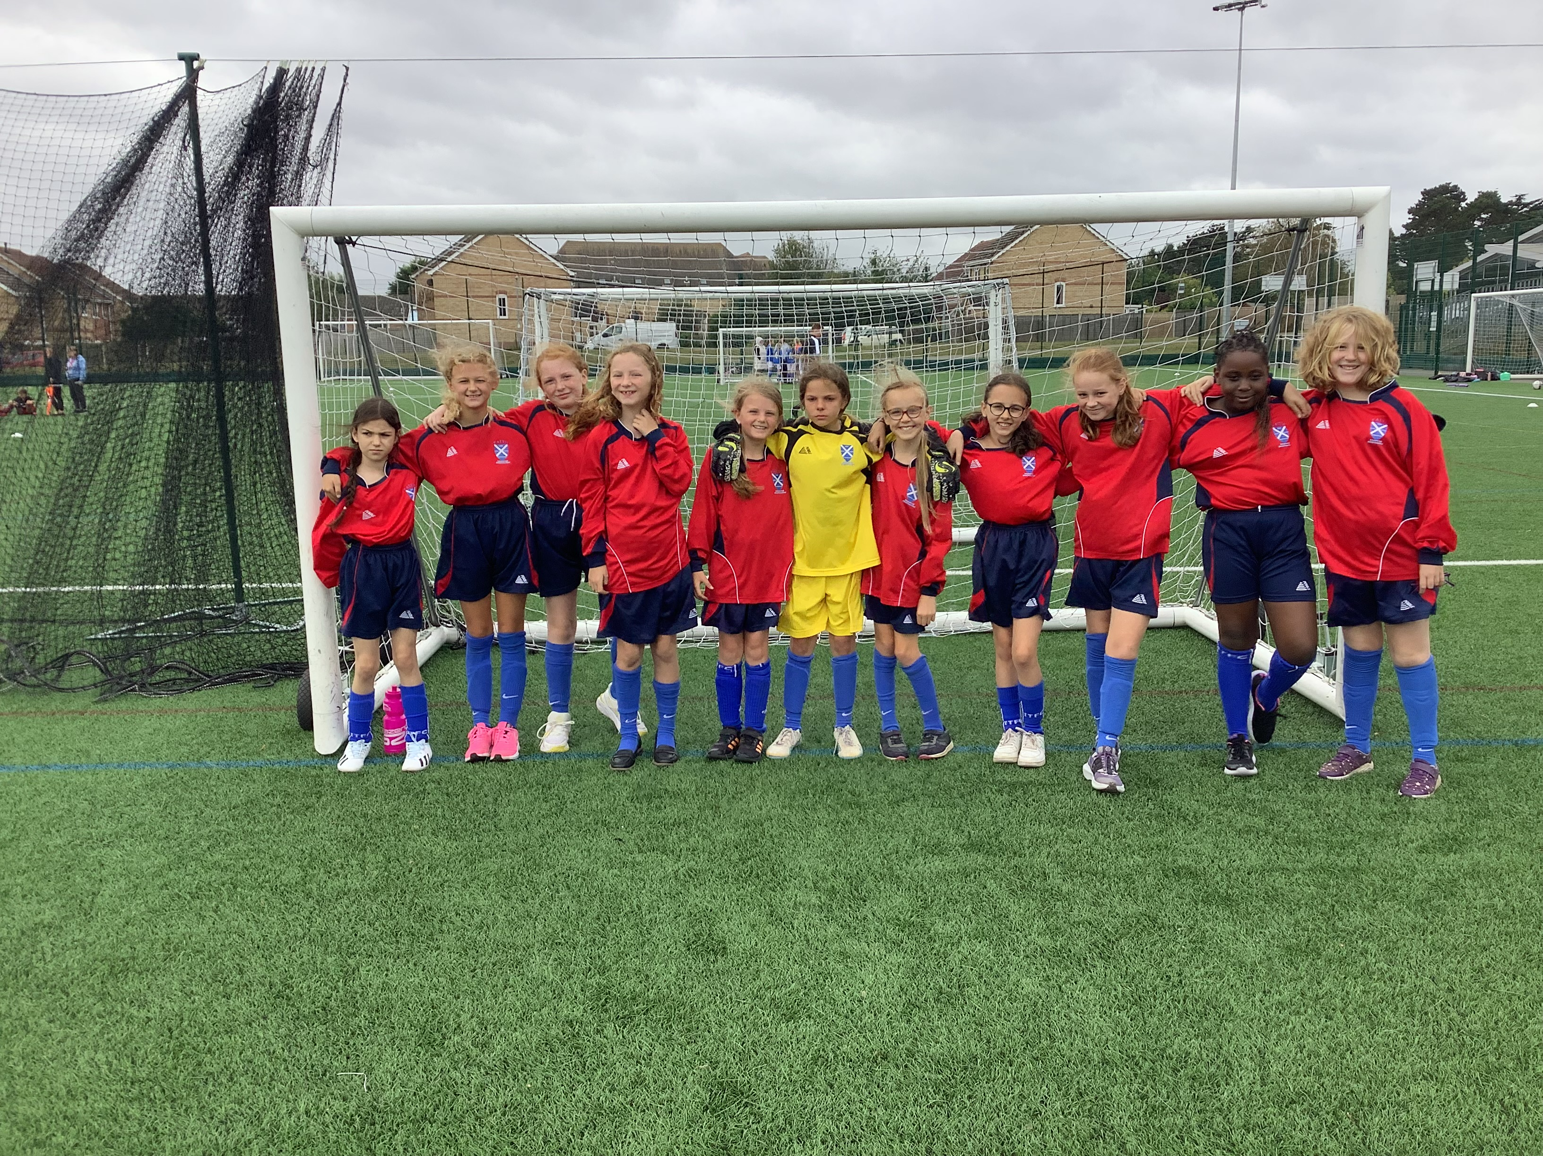

On the 19th September 2023, Arna, Aimee, Delilah, Georgia, Isla, Lizzy, Ruby, Eva, Elissa, Matipa and Lilly took part in the all-girls football competition at Ramsey school.

We had 5 games in total. In our first game we won 2-0, with Aimee and Isla scoring the goals. In our 2nd game we lost 2-0, in our 3rd game we lost 1-0, in our 4th we lost 3-0 and in our final game we lost 5-0. This is the first time the girls have played in a tournament and as a team, the girls did St Andrews very proud. The girls also showed excellent team work and honesty.

All members of our team have improved immensely week on week and in training have worked very hard. The teams were all very good at the tournament and the matches were really close. Overall, we came 4th out of 5 teams. Well done girls!

