Boccia L2 Competition

Date: Wednesday, 7th November 2018

Venue: Ramsey Academy

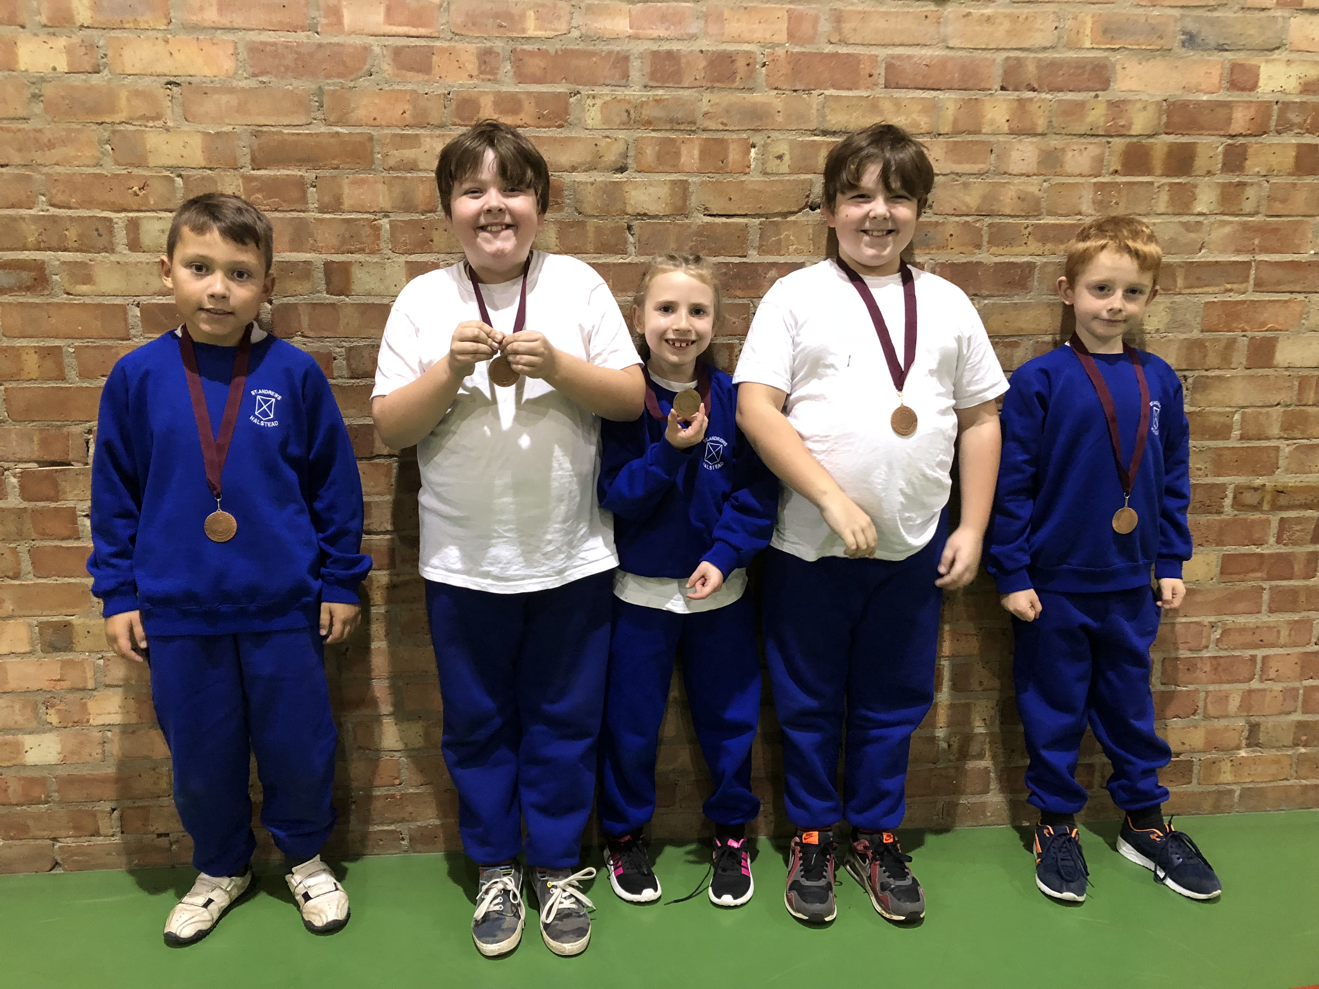

Congratulations to Adam & Ewan Finch, Rhys Simpson, Emily Burlong and Joshua McPherson who represented St Andrew’s for the first time at the recent L2 Boccia competition. The children worked well as a team and played 3 games in their group, winning two which meant they went through to the Semi-Final. They won their Semi Final and played an incredible game to win their final match and as a result, the overall competition. This means that St Andrews now progress to the L3 County final in January 2019. What an amazing result, especially as none of our team had ever played Boccia before!!!

